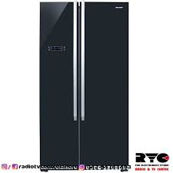

SJ-X640-BK3

* Cooling Technology No Frost
* Style Side By Side
* Color Black
* Material Metal
* **Rs.179,900**